**Group Report**

**Final Project: Introduction to Big Analytics**

**Work group consists of the following students:**

1. Marina Golberg
2. Sigli Mumuni
3. Joost Bloos

**Workload distribution**

Although the table below seems to suggest a strict separation of project tasks and workload distribution, we as project members feel that everyone has contributed an equal amount of time and a fair sharing of the overall workload to accomplish this project.

|  |  |
| --- | --- |
| Summary and report scoping/editing | Joost |
| Data preparation | Marina |
| Predictive modelling | Sigli |
| Performance measurements | Joost |
| Conclusions and recommendations | Sigli/Joost |
| Bonus marks for creativity | Marina - sklearn’s preprocessing tool  Sigli – Random Forest  Joost - Tableau |



**REPORT**

**(**dated April 2021)

Table of Contents

Executive summary 3

Recommendations 3

Next steps: 4

Introduction 5

Clarifying the business problem 5

Identifying the stakeholders 5

Mapping the business problem to a data science problem 5

Describing the analytical approach 5

Data Preparation 6

Description of churn dataset 6

Customer concentration and churn by State 7

Cleansing of the churn dataset 8

Correlation 8

Outliers 8

Characteristics of dataset before and after cleansing 10

Other observations 10

Distribution of numerical attributes 11

Imbalanced class distribution 12

Summary 12

Classification algorithms 13

Decision Tree 13

Naïve Bayes 13

Random Forest 13

Approach 14

Determine performance measures 14

Determining the right strategy for the data split 15

Training the models 15

Comparing results of algorithms 16

Random Forest - Classification Tree 17

Feature importance 18

Factors that contribute to churn 18

Recommendations 21

Next steps: 21

# Executive summary

Customer churn refers to a situation in business where customers withdraw from a service or cease to carry on a business relationship with our company. Customer churn can be detrimental to a business’s bottom line as it takes away valuable income streams and is the result of a negative customer experience.

Using data collected from over 2600 customers, we will attempt to create a model to predict future customer churn more reliably as it relates to our company. This model can provide guidance in answering questions such as:

1. What factors contribute the most to customer churn?

2. Which groups of customers are more likely to churn?

3. What can the business do to prevent customers from churning?

The data science team has undertaken an analysis of the churn dataset using a wide range of data analytical tools including Python, R and Tableau. We have preprocessed the data to ensure it is clean and consistent. Followed by an exploratory data analysis to find relationships among the different attributes and how they can help us further understand the issue of predicting customer churn. Finally, we have undertaken the task of building machine learning models using three classification algorithms: Naive Bayes, Decision Tree, and Random Forest.

The goal of these classification models is to help the company more reliably predict future customer churn before it occurs in order to take the necessary steps to prevent it from happening.

Based on the significantly better results generated by the Random Forest algorithm and the classification model it generated, we found high reliability and high predictability of the following top-5 factors that contribute most to customer churn:

* Day Charge, which alone contributes close to 23.5% of the explained variance, and;
* International Plan with a percent importance of 21.4%.

These two variables alone contribute close to half of the variance in the model, as well as:

* Evening Charge
* Customer Service Calls
* International Charge

From the data, we can tell that customers with a high call volume have on average higher churn rates. Customers with an international plan also have on average higher churn than those on a domestic call plan.

## Recommendations

We recommend doing a price and rate plan comparison with our competitors. If price sensitivity is a concern, perhaps discount plans can be offered to these high valued customers with higher-than-average call volumes.

In addition, a customer survey can be conducted to find out if there are any specific pain points in the customer experience that the company should be aware of. This may help to better understand why customers with an international plan have a higher churn than this on a domestic call pan.

Also, our call centers should system track the frequency of a specific customer calling our service centers, as a customer service call could be an indication that the customer is more likely to churn within a certain time frame. Pending the customer’s complaint, a more competitive offer can be made to this specific group of customers and potentially mitigate the number of customers churning.

Alternatively, our call center associates could request churning customers why specifically they cancel their contract and to which competitor they are switching over to.

## Next steps:

1. We request to seek stakeholder agreement based on the preliminary results described in this report.
2. Develop an action plan with the business to start tracking the attributes mostly linked to churn.
3. Develop a mitigation or response plan to help manage churn and bring down overall churn rates.
4. Test the effectiveness of the response plan by measuring and comparing actual churn month-over-month.
5. Link the customer churn data set to other sources of information external to the company such as income, education, homeownership, etc. to gain increased knowledge of our current customer base as well as potential future customers.
6. Socialize the concept and interpretation of classification models within the organization as perhaps other managers may be interested in a similar analysis to help grow their business.

A final recommendation is to do a periodic review of our classification model and the resulting attributes that are mostly linked to churn to assure continuous validity of our conclusions and churn mitigation strategies in the near future.

# Introduction

## Clarifying the business problem

The company would like to know in advance which customers have a high risk of churning in the near future. With this knowledge additional mitigating measures may be put in place to reduce future churn rates.

## Identifying the stakeholders

Management has initiated the request as they have shown interest to be able to anticipate and reduce future customer churn rates. At the initial stage, stakeholders involved are executive management and the data scientist team.

## Mapping the business problem to a data science problem

Initial task is to characterize customer churn through data analytics methods. As management would like to understand and be able to predict future churn, we have identified this as a classification problem which allows for predictive modelling.

## Describing the analytical approach[1]

Classification is the process of learning a model that describes different classes of data. The classes are predetermined based on the dataset used. This type of activity is also called supervised learning. Once the model is built, it can be used to classify new data.

The first step is, learning the model which is accomplished by using a training set of data that has already been classified. Each record in the training data contains an attribute, called class label, which indicates which class the record belongs to. The model that is produced is usually in the form of a decision tree or set of rules.

Some of the important issues with regards to the model and the algorithm that produces the model include:

* the model’s ability to predict the correct class of new data;
* the computational cost associated with the algorithm, and;
* the scalability of the algorithm.

The recommendations in this report will concentrate on the model’s ability to predict the correct class of new data.

Prior to discussing the specific algorithms used in this report, we will discuss and describe the characteristics of the churn dataset that will be used in the classification process.

# Data Preparation

Prior to running the classification algorithms, the data science team has explored the dataset with the following observations:

## Description of churn dataset

The churn dataset has 21 attributes with 3,333 observations including a binary class attribute about churn. The dataset consists of the company’s client information such as the customer’s phone plan with the company and phone number, as well as call activity measured in number of calls and time measured in minutes during daytime, nighttime, and international calls including voicemail activity.

A detailed description of the attributes in the dataset used are given below:

* **State:** Customer’s state.
* **Account Length:** Integer number showing the duration of activity for customer account.
* **Area Code:** Area code of customer.
* **Phone Number:** Phone number of customer.
* **Inter Plan:** Binary indicator showing whether the customer has international calling plan.
* **VoiceMail Plan:** Indicator of voice mail plan.
* **No of Vmail Mesgs:** The number of voicemail messages.
* **Total Day Min:** The number of minutes the customer used the service during day time
* **Total Day Calls:** Discrete attribute indicating the total number of calls during day time.
* **Total Day Charge:** Charges for using the service during day time (continuous data type).
* **Total Evening Min:** The number of minutes the customer used the service during evening time.
* **Total Evening Calls:** The number of calls during evening time.
* **Total Evening Charge:** Charges for using the service during evening time.
* **Total Night Min:** Number of minutes the customer used the service during night time.
* **Total Night Calls:** The number of calls during night time.
* **Total Night Charge:** Charges for using the service during night time.
* **Total Int Min:** Number of minutes the customer used the service to make international calls.
* **Total Int Calls:** The number of international calls.
* **Total Int Charge:** Charges for international calls.
* **No of Calls Customer Service:** The number of calls to customer support service.
* **Churn:** Class attribute with binary values (True for churn and False for not churn).

The attributes in the churn dataset consist of:

* nominal data types such as State, Inter Plan, and vmailplan;
* ordinal data types, for example: Account Length and VoiceMail Plan, and;
* quantitative data types for attributes that includes the number of voicemail messages, and attributed that measure minutes, calls, and charges.

We built a custom function using sklearn’s preprocessing tool to encode all 3 nominal variables to numerical labels allowing further data-analysis.

### Customer concentration and churn by State

The customer phone data and churn data allow us to present the company’s client base and churn rates geographically for all states in the US, as presented in the two graphs below. It appears that there is no significant or high geographical concentration risk within the dataset other than perhaps for the state of West-Virginia; however, we have not plotted this information based on the number of capita in each state.

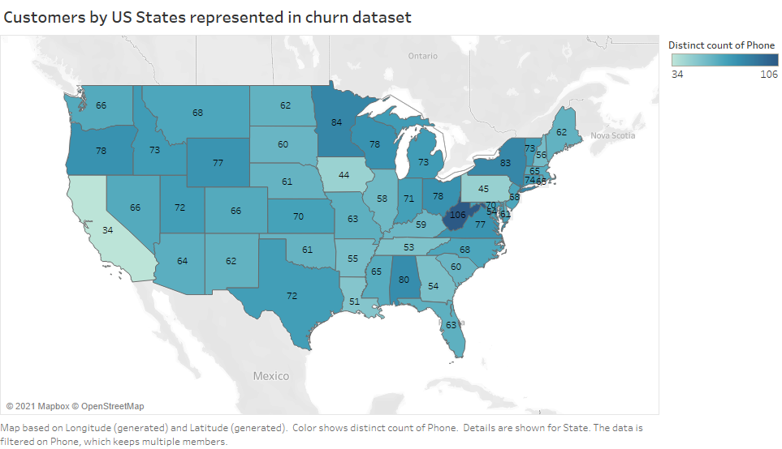

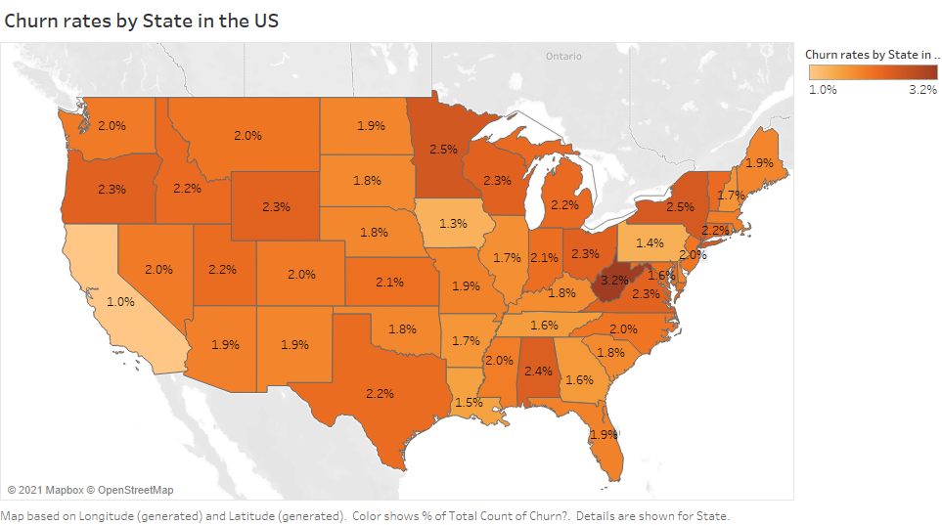

## Cleansing of the churn dataset

### Correlation

The dataset has been cleansed by removing attributes that show a high correlation (0.999) with the attribute “**Total Charge**” which because of this high correlation are not necessary for further analysis and have been removed from the dataset, as follows:

* **Total Evening Min**
* **Total Night Min**
* **Total Int Min**
* **Total Night Min**

The following graphs is a visual of the correlation between the different attributes. As it appears most attributes have low or no correlation between them.

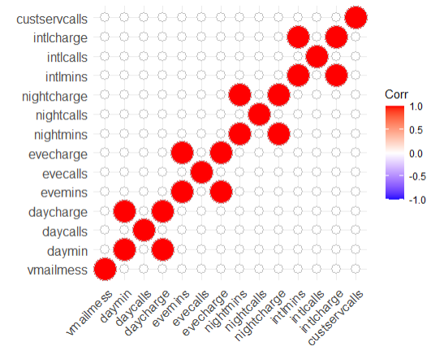

### Outliers

The dataset has been further cleansed by identifying and removing so-called outliers.

Outliers are observations that are numerically distant from the rest of the data. When reviewing the two box plots, as shown below, there are data points located outside of the so-called “whiskers” of the boxplot i.e. outside 1.5 times the interquartile range above the upper quantile and below the lower quantile.

We recommend removing the outliers as they could be an indication of incorrectly collected information, but more so we believe that the sample size is not materially impacted by dropping of these questionable outliers or that the interpretation of results is critical to its outcome[2].

The box plot shows the results before (left) and after removing (right) of the outliers.

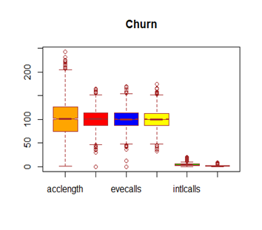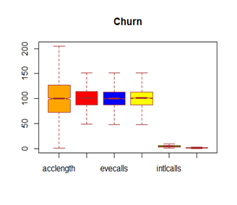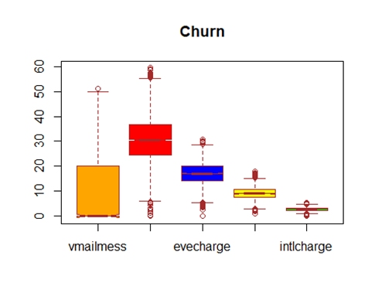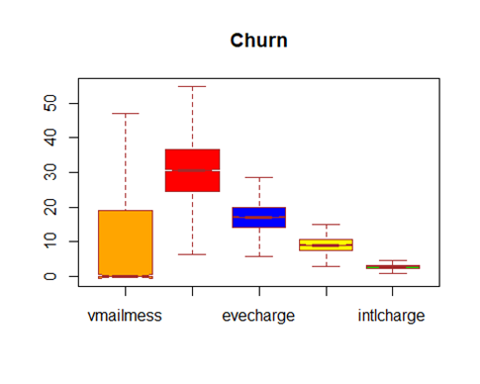

### Characteristics of dataset before and after cleansing

With the use of R, the dataset has been summarized for each attribute in the table below, before and after cleaning of the dataset, for its more numerical and statistical characteristics, as follows:

* Minimum value
* 1st quantile (threshold of first 25% of observations)
* Median
* Mean
* 3rd quantile (threshold of 75% of observations)
* Maximum value
* Standard deviation

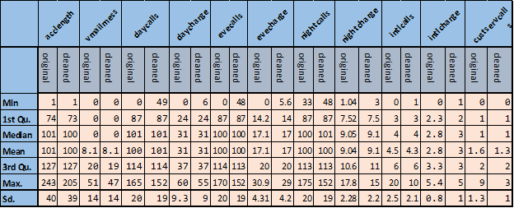

When comparing the before and after cleansed datasets for each attribute, it is noticeable that by removing the outliers, the minimum values are seeing an increase and the maximum values a decrease, bringing both minimum and maximum closer to the mean, and more so reducing the standard deviation as one would expect when removing outliers.

### Other observations

Also, after investigation, we can confirm that the remaining dataset appears to have no missing values as indicated by “NA”.

For ease of reference, all “True” and “False” values within the attribute churn have been replaced by “yes” and “no”.

|  |  |
| --- | --- |
| **Before cleansing** | **After cleansing** |
| churn -> "yes" 483" observations | churn cleaned-> "yes" 302 observations |
| churn -> "no" 2,850 observations | churn cleaned -> "no" 2,484 observations |

As a result of the data cleansing process, the dataset, which we will use for further presentation, has now been reduced to 16 attributes consisting of a total of 2,786 observations.

### Distribution of numerical attributes

When summarizing and characterizing the data set, we can conclude that most attributes have a normal distribution and as a result the dataset is centered around the mean; however, for **No of Calls Customer Service** and **Total Int Calls** the dataset is slightly skewed to the right, as per the graphs presented below.

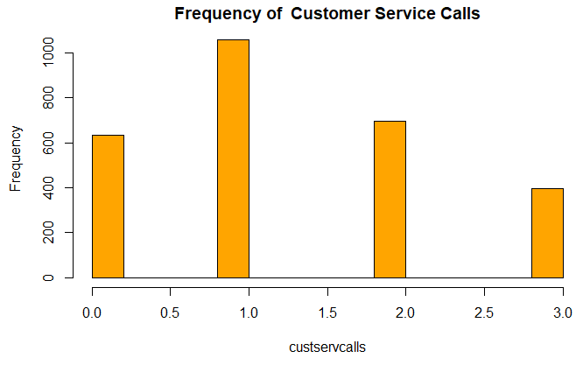

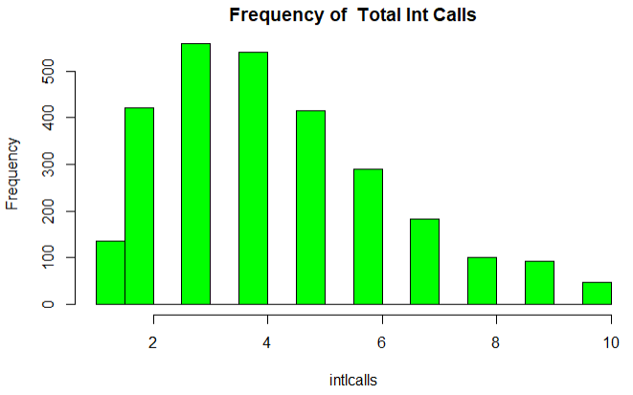

Skewness to the right is an important observation as it may tell us that the mean may not be the best indicator to reflect the “centerness” of the dataset and as a result the median or mode is a perhaps a better indicator.

Although there are various ways to create a better fitting distribution[3], we have concluded that the skewness of both attributes is not significant to justify a correction as the values for both mean, median, and mode lie within each others proximity:

* No of Calls Customer Service: mean 1.3, median 1, mode 1.
* Total Int Calls: mean 4.3, median 4, mode 3.

### Imbalanced class distribution

From our initial observation, we established that the dataset has an imbalanced class distribution by a ratio of 1:6 with the majority class being the “no” class[4].

Working with imbalanced datasets can be problematic if there are too few examples of the minority class to incorporate into the decision boundary. Subsequently, the model becomes extremely good at predicting the majority class but does not do so well with the minority class.[5]

We hope to improve our models' performance by balancing the dataset, so it has equal numbers of both classes. To do this, we will be implementing the so-called “oversampling” technique. As the name suggests, this is achieved by oversampling the minority class in the training dataset. Examples are drawn from the minority class and duplicated to match their occurrence with the majority class. This only serves to balance the dataset without amending or including any additional information.[6]

While many approaches exist to accomplish a more balanced dataset, we have used the most widely used algorithm called the Synthetic Minority Oversampling Technique, or SMOTE algorithm.

### Summary

As part of the data preparation process, we have scrubbed the dataset as follows:

* Removed attributes with a strong correlation to the attribute “Total Day Charge”.
* Reviewed and removed any outliers.
* Established that there are no missing values in the dataset.
* Reviewed the dataset for its distribution and determined that two attributes are slightly, but not significantly skewed to the right.

After completion of the data cleansing process, we have established two datasets which we will be used to run our algorithms, as follows:

* Filtered and imbalanced dataset
* Filtered and balanced dataset

# Classification algorithms

Three classification algorithms have been suggested to predict future churn:

* Decision Tree;
* Naïve Bayes, and;
* Random Forest.

We will briefly describe all three algorithms and the interpretation of their outputs in the following section.

## Decision Tree[7]

The decision tree builds classification or regression models in the form of a tree structure. It breaks down a dataset into smaller and smaller subsets while at the same time an associated decision tree is incrementally developed. The result is a tree with decision nodes and leaf nodes. A decision node has two or more branches. Leaf node represents a classification or decision. The topmost decision node in a tree which corresponds to the best predictor is called the root node. Decision trees can handle both categorical and numerical data.

## Naïve Bayes[8]

Naive Bayes is a [machine learning algorithm](https://www.upgrad.com/blog/types-of-machine-learning-algorithms/) we can use to solve classification problems. It is based on the Bayes Theorem. It is one of the simplest yet powerful algorithms in use and finds applications in many industries. Naive Bayes is a classification technique based on an assumption of independence between predictors which is known as Bayes’ theorem. In simple terms, a Naive Bayes classifier assumes that the presence of a particular feature in a class is unrelated to the presence of any other feature. One of the biggest advantages of Naive Bayes is it requires relatively small amounts of data to train the model. In this report, we implemented the Gaussian Naïve Bayes algorithm for classification.

## Random Forest

The Random forest algorithm is an ensemble method used mainly for classification and regression. Unlike decision trees, random forests grow not one, but a multitude of decision trees. Each tree gives a classification, and “votes” for that class, after which the classification with the most votes is selected from all the trees within the “forest”.[9]

We made the decision to include the random forest algorithm as it is well established that growing an ensemble of trees (as opposed to a single tree) and allowing them to vote for the most popular class will significantly improve classification accuracy. But beyond that, unlike decision trees, random forests do not overfit, are able to balance error in classification caused by imbalanced data sets, give estimates of what variables are important, and several other advantages.[10]

## Approach

To compare the outputs of machine learning models that have different features, we will be using cross validation as a way to analyze how well our supervised learning models are performing on the dataset that was not part of the data utilized to train the model i.e. how well the model generalizes[11].

First, we created a baseline model by creating a training set using the entire features set (including all attributes of relevance after the data cleaning process) and evaluating its performance using selected metrics, which we will discuss in the section below, on the test set.

Secondly, we train the same classification algorithm on selected features and evaluate its performance on the test set using the same selected metrics.

Finally, we compared the performance of different training models by using selected performance metrics.

## Determine performance measures

When measuring how well the data mining algorithm is performing on our dataset, we will apply the evaluation metric of the so-called 2x2 confusion matrix or also known as error matrix[12].

The confusion matrix is a specific table layout that allows visualization of the performance of an algorithm. Each row of the [matrix](https://en.wikipedia.org/wiki/Matrix_(mathematics)) represents the instances in a predicted class, while each column represents the instances in an actual class. The name stems from the fact that it makes it easy to see whether the system is confusing two classes i.e. commonly mislabeling one as another.

As follows:

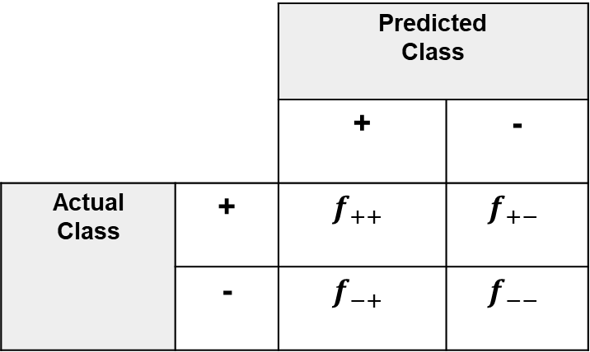

$f_{++}$: measure all “True” positives (TP) which indicates that the outcome of the model or predicted value matches that of the actual value. Vice versa $f_{--}$ (TN):measures all “True” negatives which also indicates how well the model is performing. On the other hand, $f_{-+}$ (FP)and $f_{+-}$ (FN)measures a mismatch between the actual value and the predicted value by the model.

Based on these measurements, the confusion matrix constructs three different evaluation metrics as follows:

* Accuracy is measured by: $\frac{f_{++}+ f_{--}}{T}$
* Recall is measured by: $\frac{f_{++}}{f_{++}+f_{±}}$
* Precision is measured by: $\frac{f_{++}}{f_{++}+f_{+-}}$

The evaluation method of the confusion matrix allows for a more detailed analysis than mere proportion of correct classifications, measured by accuracy. As discussed, Accuracy only will yield misleading results if the data set is imbalanced; that is, when the numbers of observations in different classes vary greatly.

The F-score is another evaluation metric which represents the harmonic mean of the precision (p) and recall (r) values. That is:

F = $\frac{2pr}{p+r}$

High precision is achieved almost always at the expense of recall and vice versa. It is a matter of the application’s context whether to tune the system for high precision or high recall. F-score is typically used as a single measure that combines precision and recall comparing different result sets.

One of the properties of harmonic mean is that the harmonic mean of two numbers tends to be closer to the smaller of the two. Thus, F is automatically biased toward the smaller of the precision and recall values. Therefore, for a high F-score, both precision and recall must be high.

Later in this report, we will be using the above evaluation metrics to make comparisons between the classification models.

## Determining the right strategy for the data split

To determine the baseline model, we have applied a simple train-test set to split the dataset into a training set and a test set. We chose this method as we deem the dataset to be sufficiently large enough such that samples from the original dataset can be split randomly into subsets without a negative impact on the representativeness of the original dataset. Using Sklearn, we applied a split percentage of 80% and 20% between the training set and test set respectively.

## Training the models

We built a total of 6 models, using two datasets and 3 algorithms. As our baseline models for all three algorithms, we used our original and cleansed dataset with imbalanced classes. The reason behind our choice of dataset for the baseline model is to more easily compare model performance between that of the imbalanced dataset and the balanced dataset. We decided to retain all features selected during the cleaning process (14 in total) since all features were deemed to contribute substantially to the explanation of the variance in the models as described in the section below on feature importance.

We run the three selected algorithms, first on the imbalanced dataset, and then on the balanced dataset, bringing the total number of models to six. For each of the six models, we performed an iterative process where we utilized hyper parameter tuning between the different iterations to arrive at the optimal or best performing model. With regards to the tree models for example, optimization of the decision tree classifier was undertaken by pre-pruning techniques such as tweaking the maximum depth as a control variable for the expansion of nodes. The “splitter” parameter also enabled us to alternate between “best” which chooses the best split and “random” which selects the best random split. Aside from pre-pruning parameters, “criterion”, which is the function that measures the quality of a split, was used to alternate between “gini” for Gini impurity and “entropy” for information gain. Unique to the random forest algorithm, is the “n-estimators” parameter, which allowed us to specify the number of trees in the forest.

At the conclusion of the model building process and having derived the best performing model for each of the 6 variations, we proceeded to run a comparison using selected performance metrics as explained in the next section.

# Comparing results of algorithms

In this section, we will compare the results using the evaluation metrics as described earlier.

After running the algorithms, we have collected all the measurements for the imbalanced (baseline model) and balanced dataset including true positives, true negatives, as well as false positives and false negatives and calculated the evaluation measures for accuracy, recall, and precision, as presented in the tables below.





As per table below, looking at the results of our evaluation metrics for Accuracy, Recall, and Precision, we can conclude that the balanced dataset shows a significant improvement over the use of the imbalanced dataset especially for the decision tree and Naïve Bayes algorithm. However, we can also conclude that the Random Forest algorithm shows consistently high results for all three-evaluation metrics of the confusion matrix as it relates to the balanced datasets which indicates the high predictive capability of the Random Forest model.

|  |  |  |  |  |  |  |  |  |
| --- | --- | --- | --- | --- | --- | --- | --- | --- |
| **Classification**  **Models** | **Imbalanced**  **dataset** | | | | **Balanced**  **dataset** | | | |
| **Accuracy** | **Recall** | **Precision** | **F-score** | **Accuracy** | **Recall** | **Precision** | **F-score** |
| Decision Tree | 0.92 | 0.63 | 0.66 | 0.64 | 0.92 | 0.92 | 0.93 | 0.92 |
| Naïve Bayes | 0.88 | 0.42 | 0.38 | 0.40 | 0.81 | 0.92 | 0.88 | 0.90 |
| Random Forest | 0.95 | 0.96 | 0.59 | 0.73 | **0.95** | **0.96** | **0.95** | **0.95** |
| ***Based on 836 observations*** | | | | | ***Based on 1,491 observations*** | | | |

The same for the Random Forest classification model can be concluded for the evaluation metric of the F-score, as its high F-score indicates that both precision and recall must be high, as it also appears from the results in the table above.

The best selected decision tree as generated by the Random Forest Classification is presented on the next page.

## Random Forest - Classification Tree

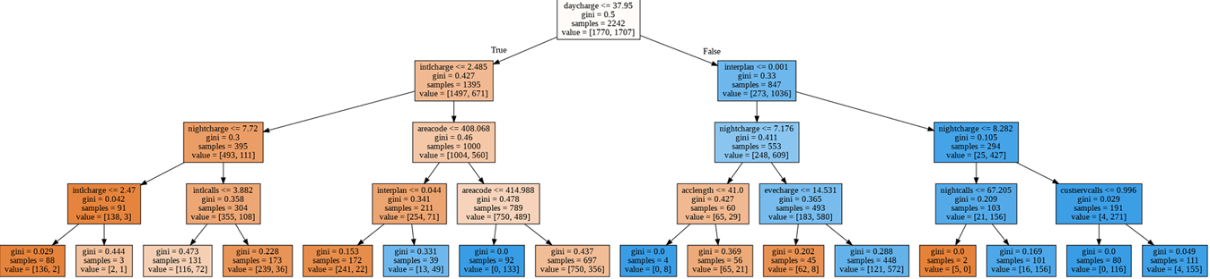

## Feature importance

The bar chart below shows all the features used in building our random forest model with the balanced dataset, ranked according to importance. This ranking is based on a numeric representation of how much of the explained variance in the model is contributed by the feature in question. These computed values describe how important the features are for the machine learning model and can shed more light on how important those features are in the overall approximation of the relationship between the predictor variables and target variable. The scores on the x-axis of the bar chart represent relative importance, meaning the percent importance of each feature.

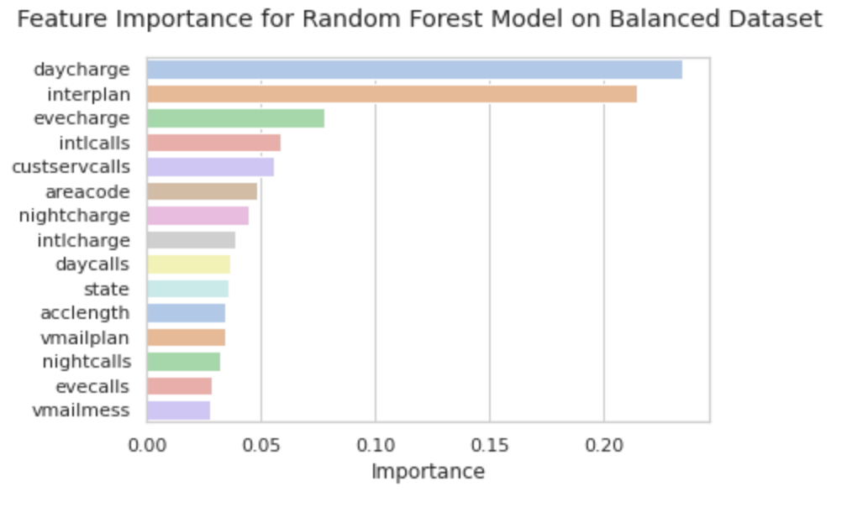

In the bar chart, we see here that the most important feature in our decision tree to explain and predict churn is Day Charge, which alone contributes close to 23.5% of the explained variance, followed by International Plan with a percent importance of 21.4%. These two variables alone contribute close to half of the variance in the model, after which Evening Charge, Customer Service Calls and International Charge make up the rest of the top 5 performing features.

In the next section, we conduct additional analysis on these five attributes in an attempt to shed more light on how they relate to the target variable “churn”.

## Factors that contribute to churn

One of the key objectives of this project is to identify the most important factors that contribute to customer churn. This is key to revealing which groups of customers are likely to churn, so as to implement the necessary interventions to prevent this from happening.

Having uncovered the most important attributes in our best performing classification model, our next goal is to attempt to draw linkages between these attributes and the target variable ‘churn’.

For this analysis, we revert to the original dataset, with all outliers intact since our goal is to more closely analyze real world customer behavior.

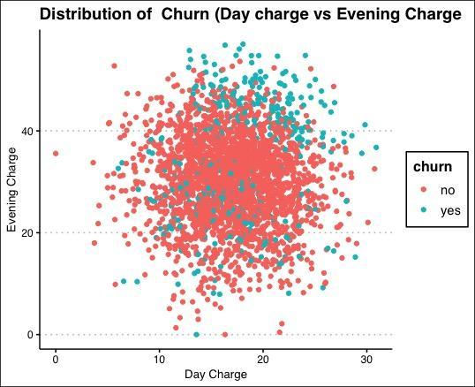

Two important factors that contribute to churn are Day Charge and Evening Charge, which in turn are highly correlated with Day Calls and Evening Calls. Looking at the scatter plot above, it can be seen clearly how these attributes relate with the target variable. Churning customers have a higher Day and Evening charge on average than non-churning customers. This could perhaps be an indication that our rate plans become less competitive, or our customers become more price sensitive as their overall phone charges increase due to increased call volume or call duration.

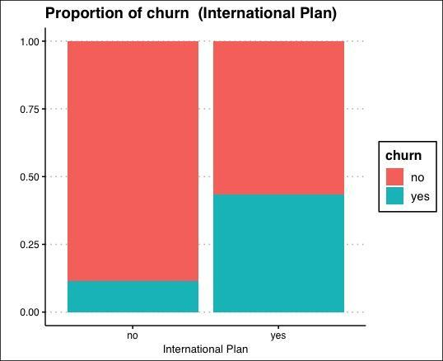

Customers on an international plan have a higher churn rate on average than customers who aren’t. It is not immediately clear why this is the case, as it is an issue that will require additional investigation. Perhaps surveys can be conducted to find out if there are any pain points in the customer experience that the company should be aware of. Nevertheless, we can conclude from the bar charts above that customers on an international plan are more likely to churn compared to customers who aren’t.

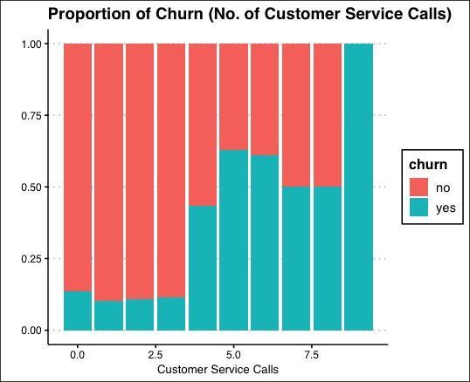

Quite expectedly, the number of customer service calls is highly correlated with the likelihood of a customer churning. Frequent customer service calls is indicative of frustration with a product or service, and is usually a precursor to churn. This is confirmed from the above chart. Here, we see a sudden spike in churn rates with an increase in the number of customer service calls.

Any strategy that hopes to tackle the issue of customer churn as it relates to the company, will have to include the four main drivers of churn we have outlined above. In the next section, we propose concrete steps the company can take to improve customer satisfaction and reduce the rate of churn.

# Recommendations



The telecom industry is highly saturated with low customer growth rates. Any effort to retain and increase valuable market share must focus heavily on customer retention. Based on our findings, we propose the following strategies to increase our understanding of customer retention and control the rate of churn in the company:

1. As customers with a high call volume and high call duration have on average higher churn rates, we recommend doing a price and rate plan comparison with our competitors. If price sensitivity is a concern, perhaps discount plans can be offered to these high valued customers with high call volumes.
2. In addition, a customer survey can be conducted to find out if there are any specific pain points in the customer experience that the company should be aware of. This may help to better understand why customers with an international plan have a higher churn than those on a domestic call pan.
3. Also, our call centers should system track the frequency of a specific customer calling, as a customer service call could be an indication that the customer is more likely to churn within a certain time frame. Pending the customer’s complaint, a more competitive offer can be made to these customers and potentially mitigate the number of customers churning.
4. Alternatively, our call center associates could request churning customers why specifically they cancel their contract and to which competitor they switched over to.

# Next steps:

1. We request to seek stakeholder agreement based on the preliminary results described in this report.
2. Develop an action plan with the business to start tracking the attributes mostly linked to churn.
3. Develop a mitigation or response plan to help manage churn and bring down overall churn rates.
4. Test the effectiveness of the response plan by measuring and comparing actual churn month-over-month.
5. Link the customer data set to other sources of information external to the company such as income, education, homeownership, etc. to gain increased knowledge of our current customer base as well as potential future customers.
6. Socialize the concept and interpretation of classification models within the organization as perhaps other managers may be interested in a similar analysis to help growth their business.

The data analyst team views this report as a preliminary review as we suggest being more actively involved in the selection of the sample churn data set, understand and choosing the time frame over which the churn data set is extracted, and understand if perhaps a larger data set is available to run our classification algorithms.

A final recommendation is to do a periodic review of our classification model and the resulting attributes that are mostly linked to churn to assure continuous validity of our conclusions and churn mitigation plans in the near future.

End

1. Source: Fundamentals of database systems. Elmasri and Navathe, 7th Edition 2016.
2. [When Should You Delete Outliers from a Data Set? - Atlan | Humans of Data](https://humansofdata.atlan.com/2018/03/when-delete-outliers-dataset/)
3. [1.3.3.14.6. Histogram Interpretation: Skewed (Non-Normal) Right (nist.gov)](https://www.itl.nist.gov/div898/handbook/eda/section3/histogr6.htm)
4. Out of a total of 2,699 records, a total of 2,307 customers are classified as “no” while the remaining 392 are classified as “yes”.
5. Brownlee, J (2020) SMOTE for Imbalanced Classification with Python (Last accessed at: <https://machinelearningmastery.com/smote-oversampling-for-imbalanced-classification/> on 12th April, 2021)
6. Chawla, N et al (2002) SMOTE: Synthetic Minority Over-sampling Technique. Journal of Artificial Intelligence Research 16 (2002) 321–357
7. https://www.saedsayad.com/decision_tree.htm
8. [Naive Bayes Explained: Function, Advantages & Disadvantages, Applications in 2021 | upGrad blog](https://www.upgrad.com/blog/naive-bayes-explained/).

   [What Is Naive Bayes?. Before we build a classifier, let’s… | by Navjot Singh | The Startup | Medium](https://medium.com/swlh/naive-bayes-27c896012899).
9. [Hastie, Trevor](https://en.wikipedia.org/wiki/Trevor_Hastie); [Tibshirani, Robert](https://en.wikipedia.org/wiki/Robert_Tibshirani); [Friedman, Jerome](https://en.wikipedia.org/wiki/Jerome_H._Friedman) (2008). [The Elements of Statistical Learning](http://www-stat.stanford.edu/~tibs/ElemStatLearn/) (2nd ed.). Springer.
10. Leo Breiman (2001) Random Forests. Machine Learning, 45, 5–32, 2001
11. Padmanabhan & Jenkins, 2014.
12. [Confusion matrix - Wikipedia](https://en.wikipedia.org/wiki/Confusion_matrix)